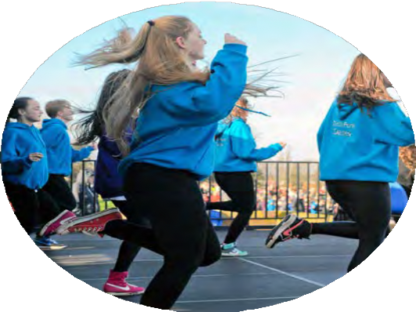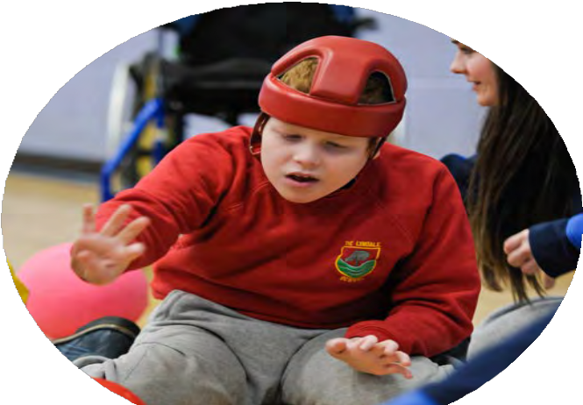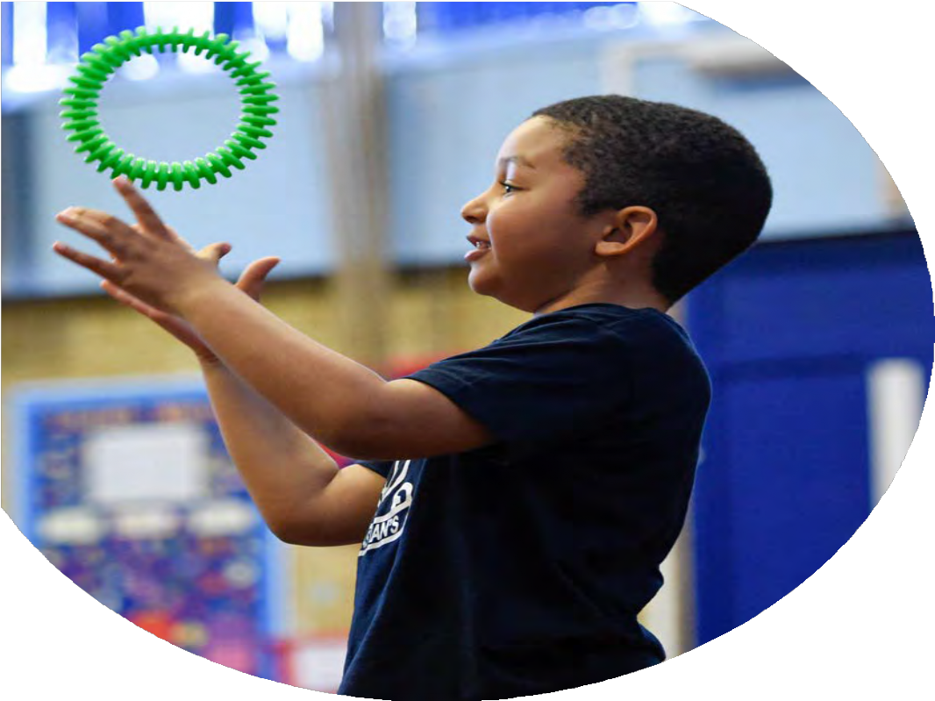

The Primary PE and sport premium

Planning, reporting and evaluating website tool

Updated September 2023

# Commissioned by

**Created by**

This template can be used for multiple purposes:

by:

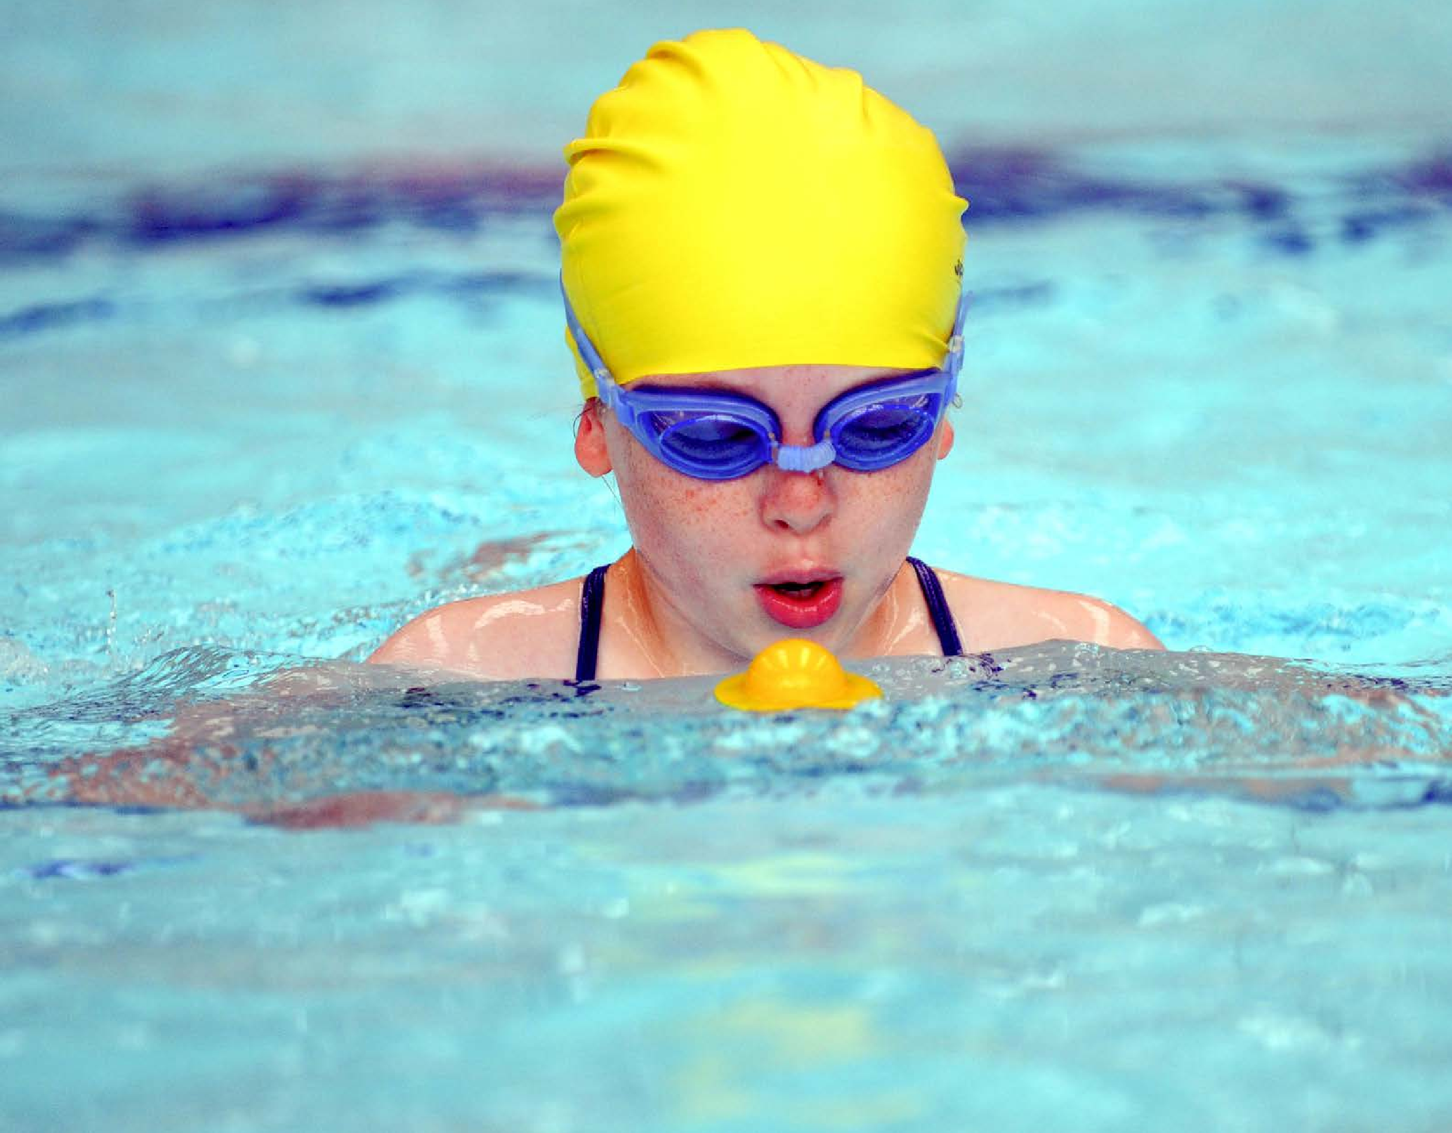

* It enables schools to effectively plan their use of the Primary PE and sport premium
* It helps schools to meet the requirements (as set out in guidance) to publish information on their Primary PE and sport premium
* It will be an effective document to support Ofsted inspections enabling schools to evidence progress in Physical Education (PE) and evidence swimming attainment, which forms part of the PE National Curriculum. We would recommend schools consider

the Intent, Implementation and Impact of any spend, as examined within the Education Inspection Framework.

It is important that your grant is used effectively and based on school need.

Schools must use the funding to make **additional and sustainable**

**improvements** to the quality of the PE, School Sport and Physical Activity (PESSPA)

they offer. This means that you should use the Primary PE and sport premium to:

* Build capacity and capability within the school to ensure that improvements made now will benefit pupils joining the school in future years
* Develop or add to the PESSPA activities that your school already offers.

**The Primary PE and sport premium should not be used to fund capital spend projects; the school’s core budget should fund these. Further detail on capital expenditure can be found in the updated** [**Primary PE and sport premium guidance**](https://www.gov.uk/guidance/pe-and-sport-premium-for-primary-schools)**.**

The Primary PE and sport premium guidance, outlines 5 key priorities that funding should be used towards. It is not

necessary that spending has to meet all the key priorities, you should select the priorities that you aim to use any funding towards.

Although completing this template is not a requirement for schools, schools are required to publish details of how they spend this funding. Schools must also outline what the impact this funding has had on pupils’ PE and sport participation and attainment and how any spending will be sustainable in the future. **All funding must be spent by 31st July 2024.**

The Department for Education has worked closely with the Association for Physical Education (afPE) and the Youth Sport Trust (YST) to develop this template and encourages schools to use it. This template is an effective way of meeting the reporting requirements of the Primary PE and sport premium.

**Review of last year’s spend and key achievements (2023/2024)**

We recommend you start by reflecting on the impact of current provision and reviewing your previous spend.

|  |  |  |
| --- | --- | --- |
| **Activity/Action** | **Impact** | **Comments** |
| Purchase of additional P.E equipment for more active play and lunchtimes.  Increase the amount of clubs available to children  Catch-up swimming lessons as there is over 50% of the cohort that have never been in a swimming pool before and over 80% of children could now swim unaided.  Continuing purchase of complete PE scheme to support the planning, teaching and assessment of the PE curriculum  Year 6 to undertake a residential outdoor experience to enhance their understanding of alternative sports. Provide a significant subsidy so all can attend and fund transport to the venue.  Mini buses to be purchased and maintained to support travel to tournaments and fixtures  Undertake sporting competitions which allow all children to participate at an appropriate level both in competitive and co-operative ways.  Wider increase of sporting activities within the academy, supporting children to be active (particularly those showing lower enthusiasm for PE) | There is a wider variety of activities on offer and children are more active within the play/lunchtimes rather than sitting on the benches.  Resources and staffing to support clubs. All clubs offered were full with at least 15 children attending each week.  74% of children could swim 25m at the end of the year.  P.E scheme is mapped out and progressive. Staff have a resource base for unit planning with a focus on age appropriate skills and games. Staff are more confident in teaching PE and have access to an up to date CPD package as needed  Pupils undertake a range of support and team building activities with links to outdoor and adventurous activities.  Children have competed in all football, netball and multi-sports activities in different competitions within KS2. This has supported children within Y3-Y4.  Enjoyment of competitive and cooperative sport. Increase sense of pride and sportsmanship.  Netball tournament  Football matches x 6 and tournament  Rounders tournament  Athletics events x 3  28 children accessed weekly maths on the move sessions delivered via time for sport. Comments from the children show their enjoyment of these sessions and the range of sports that they have experienced as a result. | Resources may need replacing due to high levels of use and increase numbers available to accommodate more pupils. Wider sporting and physical activities beyond football need to continue to be built upon  Wider variety of sporting clubs need to be offered with a focus upon EYFS and KS1  Swimming needs to be extended beyond Year 6 as there are still a high proportion of children that cannot swim 25m and the majority of families do not access swimming outside of school  Review units and look at additional training needs to support staff development  Look at continued access to the trip to support in outdoor and adventurous activities.  Wider access to other sporting competition with LA for as wider age range as possible  27 children represented the school in differing competitions. This needs to continue to be a focus now that the PE lead is back in the academy, widening the competition and year groups competing. Look at ATT sports events with Star.  Increase for next year splitting spend between SP and PP to target for maths progress. |

**Key priorities and Planning**

This planning template will allow schools to accurately plan their spending.

|  |  |  |  |  |
| --- | --- | --- | --- | --- |
| **Action – what are you planning to do** | **Who does this action impact?** | **Key indicator to meet** | **Impacts and how sustainability will be achieved?** | **Cost linked to the action** |
| To provide top to lessons to children with swimming lessons on a weekly basis during the simmer term, ensuring maximum number of children leave Y6 being able to swim.  This will be enhanced by the Open Facilities Fund £10K grant for whole school and topped up using sports premium to allow all children to have a 1 hour lesson each week for 5 weeks.  To target children who are less active and are overweight, supporting them to take part in sporting activities  Purchasing of PE platform to support the delivery of PE and staff CPD  Purchasing of sports equipment to maximize participation and widen sports  Competitions  Residential- outdoor and adventurous  Provide a wider range of sporting clubs for children to attend | Children are developing swimming skills and confidence which will impact on the number of children achieving 25m swim by the end of primary school  Increase the amount of time that children are active during the week, supporting them to recongise the importance of healthy lifestyles and exercise  Staff will have continual access to planning and CPD videos to support the delivery of high quality PE sessions  More children will be able to access sporting activities at playtime and lunchtime, widening the sports on offer  Children will take part in competitive sports across different sporting activities. This will take place within the Newcastle borough and ATT.  Children will take part in outdoor and adventurous activities  Children will be able to take part in a wider range of after school clubs including dance | Key indicator 2- Engagement of all pupils in regular physical activity  Key indicator 2- Engagement of all pupils in regular physical activity  Key indicator 1- Increased confidence, knowledge and skills of all staff in teaching PE and sport  Key indicator 3- The profile of PE and sport is raised across the school as a tool for whole school improvement  Key indicator 2- Engagement of all pupils in regular physical activity  Key indicator 4- Broader experience of a range of sports and activities offered to all pupils  Key indicator 2- Engagement of all pupils in regular physical activity  Key indicator 4- Increased participation in competitive sport  Key indicator 4- Broader experience of a range of sports and activities offered to all pupils  Key indicator 4- Broader experience of a range of sports and activities offered to all pupils | Higher percentage of children will be able to swim  Open facilities fund £10K grant will support this objective as swimming lessons can be provided for the whole school giving children some swimming skills before attending in Year 6  More pupils meeting their daily physical activity goal, more pupils encouraged to take part in PE and Sport Activities.  Staff having higher skills and confidence to teach high quality PE lessons  More pupils meeting their daily physical activity goal, more pupils encouraged to take part in PE and Sport Activities.  More pupils meeting their daily physical activity goal, more pupils encouraged to take part in sporting competitions  Children will experience a wide range of sports such as abseiling, canoeing and archery  Children will be able to be active for longer periods during the day. Children will be able to develop talents and interests | **£3000** sports premium to support top up swimming  £4000 for intervention support  £1800  £2500  £3500  £1500  £1340 |

**Key achievements 2024-2025**

This template will be completed at the end of the academic year and will showcase the key achievements schools have made with their Primary PE and sport premium spending.

|  |  |  |
| --- | --- | --- |
| **Activity/Action** | **Impact** | **Comments** |
|  |  |  |

**Swimming Data- 2023-2024**

*Meeting National Curriculum requirements for swimming and water safety.*

*Priority should always be given to ensuring that pupils can perform safe self-rescue even if they do not fully meet the first two requirements of the National Curriculum programme of study*

|  |  |  |
| --- | --- | --- |
| **Question** | **Stats:** | **Further context**  **Relative to local challenges** |
| What percentage of your current Year 6 cohort can swim competently, confidently and proficiently over a distance of at least 25 metres? | 74% | Huge improvement on last year. Children do not generally swim with their families. This year, Open Facilities grant has supported children by providing additional lessons on top of swimming offer and top up |
| What percentage of your current Year 6 cohort can use a range of strokes effectively [for example, front crawl, backstroke, and breaststroke]? | 74% | % |

|  |  |  |
| --- | --- | --- |
| What percentage of your current Year 6 cohort are able to perform safe self-rescue in different water-based situations? | 65% | All children exposed to this but only 65% passed |
| If your schools swimming data is below national expectation, you can choose to use the Primary PE and sport premium to provide additional top-up sessions for those pupils that did not meet National Curriculum requirements after the completion of core lessons. Have you done this? | Yes |  |
| Have you provided CPD to improve the knowledge and confidence of staff to be able to teach swimming and water safety? | Yes |  |

Signed off by:

|  |  |
| --- | --- |
| Head Teacher: | Laura Niemczyk |
| Subject Leader or the individual responsible for the Primary PE and sport premium: | Laura Niemczyk- Principal and PP lead  Jasmine Parry- PE lead |
| Governor: | Gemma Beckett- link governor |
| Date: | 28.07.2024 |