[1]2023-33-FI

Special Educational Needs Policy

**Review Date**

February 2023

**Ratified**

7 March 2023

**Next Review**

Septemer 2024

**Responsible Directorate**

Safeguarding





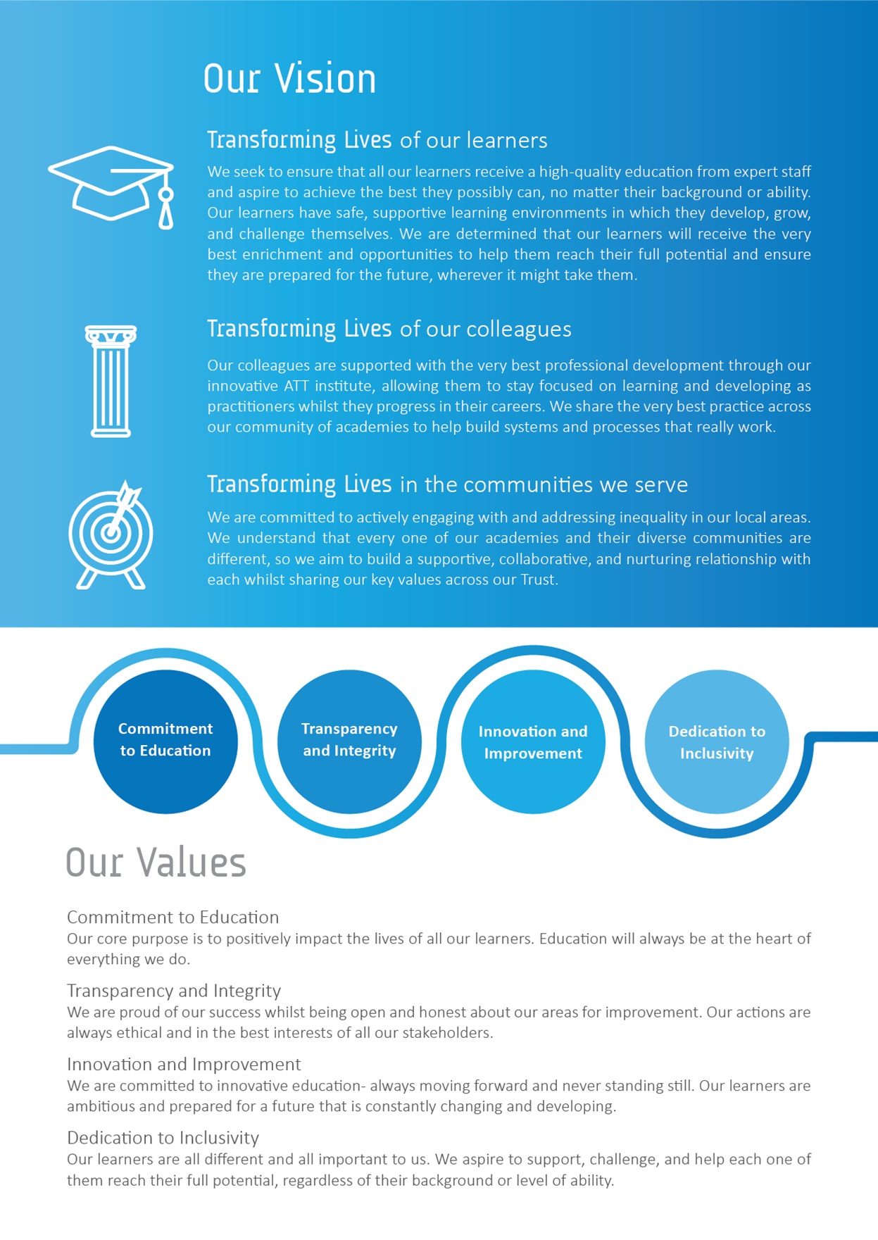

Contents

|  |  |  |
| --- | --- | --- |
|  | SEND Roles and Responsibilities | 4 |
| 1 | Aims | 4 |
| 2 | Definitions | 5 |
| 3 | Roles and Responsibilities | 5 |
| 4 | Identification & Assessment of SEN | 6 |
| 5 | Reviewing | 7 |
| 6 | Policy Links | 8 |
|  | Appendix 1- Identification & Assessment of SEN | 9 |
|  | Appendix 2- Exam Access Arrangements | 11 |
|  | Appendix 3- Staff Training | 12 |

SEND Roles and Responsibilities

**Principal**: Mrs Laura Niemczyk

**SENDCo**: Mrs Alison Cartlidge

**Nominated SEND Governor**: Iain McDonald

1 | Aims

* 1. All academies within Academy Transformation Trust seek to ensure that all our learners receive a high-quality education from expert staff and aspire to achieve the best they possibly can, no matter their background or ability. We promote a fundamental belief in equality of opportunity in the classroom and throughout The Trust.
  2. Our learners have safe, supportive learning environments in which they develop, grow, and challenge themselves. We are determined that our learners will receive the very best enrichment and opportunities to help them reach their full potential and ensure they are prepared for the future, wherever it might take them. Our support for all children within our care extends to those children with additional needs that require assistance to help them fulfil their potential.
  3. Each academy within Academy Transformation Trust will ensure that:
* The special educational needs of students will be addressed and students will not be labelled or disadvantaged by any policy or procedure operated within the Trust;
* They work in partnership with parent/carers and appropriate external agencies to support students with special educational needs and endeavour to ensure that appropriate provision is secured for any student with special educational needs in order to achieve agreed outcomes
* They have a Special Educational Needs Co-ordinator (SENCO). The SENCO will maintain and regularly review the SEND record held in respect of an individual student and co-ordinate support. However, it will be the responsibility of all staff to support individual pupils, to implement strategies suggested by the SENCO and generally be responsible for ensuring that students receive provision appropriate to their needs and agreed outcomes
* Children and young people with SEND engage in the activities of the school alongside pupils who do not have SEND
  1. All support provided and decisions taken have regard to these general principles as well as the legal framework set out in the *Children & Families Act* (2014), the *SEND Regulations* (2014) and the *SEND Code of Practice* (2015).

2 | Definitions

* 1. Under the *Children & Families Act* (2014), a child/young person will have SEND if they have a learning difficulty or disability which calls for special educational provision to be made for them.
  2. A child or young person has a learning difficulty or disability if they have:
* Significantly greater difficulty in learning than the majority of others of the same age; or
* A disability that prevents or hinders them from making use of facilities that are generally provided for others of the same age in mainstream schools in England.
  1. Special Educational Provision is education or training that is additional to, or different from, that made generally for other children/young people of the same age by mainstream schools

1. | Roles and Responsibilities
   1. The implementation of this policy will be monitored by the Trust Board and remain under constant review by the Principal and other designated senior leaders with strategic oversight of SEND and Inclusion.

* Each academy will appoint a governor with responsibility for SEN. The SEND Governor will raise SEND issues at governing board meetings; monitor the quality and effectiveness of SEND provision within the academy and work with designated senior leaders to develop the SEND policy and provision.
* The Principal will work with the SENCO and SEND Governor to develop the SEND policy and provision within the school. The Principal has overall responsibility for the provision and progress of learners with SEND.
* The SENCO will co-ordinate the academy’s approach to SEND provision and will undertake those duties set out in Chapter 6 of the SEND Code of Practice (2015).
* Class teachers are responsible for the progress and development of every student in their class and will work with the SENCO and TAs to ensure the “assess plan do review” cycle is appropriately implemented to support any student with SEND.
  1. The academy will work in partnership with students, teachers, parent/carers and, where appropriate, other external agencies to ensure that individual learning needs are addressed within the context of the school curriculum.
  2. Parents/carers of SEND students will be able to discuss the needs of their child with their child’s tutor, the Progress Co-ordinator/Head of Year or the SENCO.

1. | Identification & Assessment of SEN
   1. Information about previous special educational needs will usually accompany students upon entry to the academy and this will be used by the SENCO to make sure appropriate provision is continued.
   2. This information is collated from the transfer of school files from the previous school or early years setting and during transition meetings which are held with all the feeder schools or early years settings, in the summer term, before students start at the academy. If necessary, a strategy sheet will be drawn up for each student with SEN.
   3. On entry to secondary provision, students are assessed and the data from these tests is then analysed by the Senior Leaders, SENCO and Curriculum Leads to identify any potential areas of need. Students may then be added to the SEND Record in line with the Code of Practice guidance for SEN.
   4. The assessments taken by students upon entry include Cognitive Ability Tests (CATs) and National Reading and Spelling tests.
   5. Ongoing identification is also completed alongside the academy reporting process as data is collected and analysed in all subject areas by Curriculum Leads. If a student has not made expected progress, then interventions will be put in place regardless of need. If a member of staff identifies a student whose special educational needs are not met by the normal differentiated programme of study, then the class teacher will work with the student setting clear targets and providing greater differentiation. If the situation improves then no further action is needed. If there is no improvement the SENCO will be informed.
   6. At this point, information will be gathered. The class teacher will inform the parent/carers about the issue and there will be consultation and discussion around the proposed additional support for the student. Parent/carers, and the student where appropriate, will be involved in sharing information and agreeing outcomes. It will be decided whether it is appropriate to further monitor the student. A strategy sheet will be drawn up by the SEND team with copies shared with all staff concerned with the student ’s progress.
   7. If a parent/carer refers their child to the academy as they believe their child has special educational needs they should contact the SENCO, who will undertake investigations and appropriate assessments (with input from the relevant teachers) to see if they are achieving expected levels of progress. If the student is not making appropriate levels of progress, then internal support will be implemented in accordance with paragraphs above.
   8. In all cases, where internal support is not effective in supporting the student, a referral to the Educational Psychologist or other relevant specialist will be completed with the parent/carers’ knowledge and information and strategies for support shared with all staff.
   9. If there are no concerns regarding the student’s academic progress, then the academy will ensure appropriate differentiation continues in the classroom and interventions are put in place if appropriate.
   10. Contact details for professionals who can assess will be provided for parent/carers so they can consider a private assessment. Whenever special educational provision is being made, parent/carers and students will be involved in developing and reviewing support plans/strategies.
   11. All staff teaching students on the SEND record will be made aware of the individual needs. Directors of subject and the Special Needs team will help teachers when required to develop techniques to support differentiation and ensure that appropriate resources are available as part of the academy’s Professional Development Programme.
2. | Reviewing
   1. All students, regardless of needs, are set targets. Data collated during the academy reporting process is analysed and strategies are put in place to support those that are not achieving as expected. All SEND interventions delivered outside the classroom have Specific, Measurable, Accepted, Realistic, Time-bound (SMART) targets set to ensure that progress is made. These are recorded using Individual Education Plans (IEPs) and are monitored and reviewed against a time frame, agreed within the plan. If expected progress is not made, then the SENCO may refer to a specialist services such as an Educational Psychologist.
   2. If a student has an Educational Health Care Plan an annual review is held in accordance with legal requirements.
   3. If a student is removed from the SEND record as a result of appropriate progress, the student will continue to be monitored through the academy’s structured reporting programme by the Curriculum Leads.

6 | Policy Links

* 1. This policy should be read in conjunction with:
* SEND Information Report (updated annually)
* Equality Policy & Objectives
* Accessibility Plan (reviewed annually)
* Assessment Policy
* Curriculum Policy
* Attendance Policy
* Safeguarding Policy
  1. This policy has due regard to statutory legislation, including, but not limited to:
  + The Education and Inspections Act (2006)
  + The Health Act (2006)
  + The Equality Act (2010)
  + The Education Act (2011)
  + The Education (Independent School Standards) Regulations (2014)
  + The Schools Behaviour (Determination and Publicising of Measures in Academies) Regulations (2012)
  + The Immigration Act (2016)
  + The General Data Protection Regulation (GDPR)
  + School Discipline (Student Exclusions and Reviews) (England) Regulations (2012)

Appendix 1- Identification & Assessment of SEN

The academy's approach to the detection and management of SEND and/or learning difficulties will be guided by the Code of Practice.

The four main areas of need as per the SEND Code of Practice (2014) are:

* Communication and interaction
* Cognition and learning
* Social, emotional and mental health
* Sensory and/or physical

Students may have needs that encompass more than one of these areas and therefore detailed assessments must be undertaken in order to provide the correct support.

When considering whether a pupil has special educational needs any of the following may be evident:

* Makes little or no progress even when teaching approaches are targeted particularly in a pupil’s identified area of weakness
* Shows signs of difficulty in developing literacy or mathematics skills which result in poor attainment in some curriculum areas
* Has sensory or physical problems and continues to make little or no progress despite the provision of specialist equipment
* Has communication and /or interaction difficulties and continues to make little or no progress despite the provision of an appropriate differentiated curriculum
* Has social, emotional or mental health difficulties which substantially and regularly interfere with the pupil’s own learning or that of the class groups, despite having an individualised behaviour support programme
* Has SEND or physical needs that require additional specialist equipment or regular advice or visits by a specialist service
* Has a communication and/or an interaction difficulty that impedes the development of social relationships and cause a substantial barrier to learning.

The academy will communicate with parents or carers, if they feel the student has presented with issues such as those listed.

SEN support should take the form of a four-part cycle where actions are revisited, refined and revised as the understanding of the pupil’s needs grow and to ensure good outcomes are secured. This is known as the ‘graduated approach’ and draws on more detailed assessments, more frequent review and more specialist expertise in successive cycles in order to match interventions to the SEND of the pupil. The graduated approach has four main parts: assess, plan, do and review – see overleaf. This cycle should be completed at least twice, over two terms. If no progress is made then the academy will apply for an Education Health Care Plan (EHCP) assessment, as shown in the table.

**Formal Assessment**

A variety of formal assessments will be used to identify need. These may typically include Year 6 SATS tests, Cognitive Ability Tests, Baseline Tests done on transfer from Primary School, Word Reading, Spelling and Comprehension Tests, Dyslexia Screening Tests, Scotopic Sensitivity Testing, Access Arrangements Tests and reports from Specialist Outside Agencies.

|  |  |  |
| --- | --- | --- |
| **SEND support** | **SEND+**  (for data purposes only) | **EHCP/ST** |
| Despite high quality teaching targeted at areas of weakness:   * The pupil is failing to make progress similar to that of their peers starting from the same baseline * Progress is lower than made previously * The attainment gap is not closing between the child and their peers | When a child continues to make little or no progress despite well-founded support the school should consider involving specialists. | A child continues to make little or no progress despite advice and support from specialists. Taking advice from the local authority and from specialists the decision is made to refer to the local authority for a statutory assessment (anyone can apply to LA for an assessment).  This statutory assessment should follow on from planning already undertaken with parents and young people in conjunction with their setting and specialists. |

Appendix 2- Exam Access Arrangements

Pupils who have been diagnosed as having a learning difficulty may be eligible for extra time and / or other "access arrangements" to complete internal examinations and public examinations.

Parents/carers are asked to liaise with the SENDCO in good time, with respect to this.

Appendix 3- Staff Training

**Staff training is reviewed annually within the academy by the leadership team.**

* 1. The SENCo will be an experienced member of teaching staff and will have achieved the National Qualification for SEND Co-ordination. The SENCo has allocated time each week dedicated to overseeing the provision of SEN.
  2. Colleagues share the ethos that all teachers are teachers of children with Special Educational Needs. Through Initial Teacher Training and through continued professional development all teachers and staff are equipped to deal with a diverse range of needs.
  3. Academies will plan staff training, development and support to strengthen individuals and groups when needed.
  4. Academies will acknowledge the key role of the Special Educational Needs Coordinator, whose job description includes providing professional guidance to colleagues and contributing to their training.
  5. Both teaching and non-teaching colleagues will access training to develop their knowledge of the four areas of need: Communication and Interaction; Cognition and Learning; Social, Emotional and Mental Health and Sensory and/or Physical and the difficulties which may be linked to these.
  6. Academies will audit colleagues and training annually and provide further training to meet identified needs.

1. 2023-33-FI