**[1]2023-35-FI**

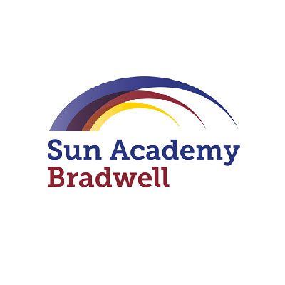

SEND

Information

Report

Academic Year 2023-2024

**Review Date**

February 2023

**Ratified**

7 March 2023

**Next Review**

September 2024

**Responsible Colleagues**

Christine Franklin, Director of Safeguarding



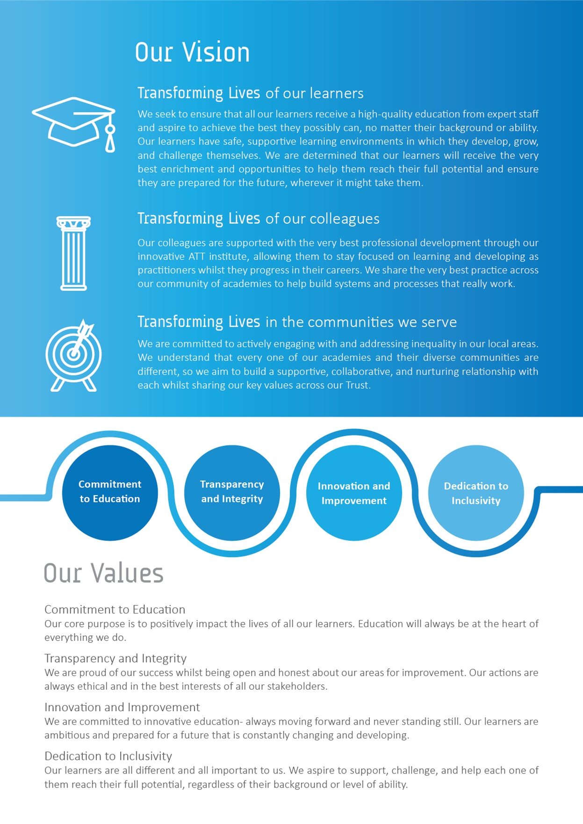

SEND Information Report

This information report has been prepared by Principal Mrs Niemczyk and SENDCO Mrs Evenson and approved by the Board of Trustees for publication on the website.

The SEN Information Report is part of a wider suite of documents relating to SEN, disability and inclusion which can be found here. In particular, it should be read alongside the academy’s SEND policy.

|  |  |  |
| --- | --- | --- |
| **The academy makes provision for the following kinds of SEN** | Sun Academy Bradwell is a Mainstream Academy which provides educational provision for children aged between 3-11 years old. We cater for a wide range of SEN needs including children with ASD, Speech and Language difficulties, Sensory or physical difficulties and children who may have a specific learning difficulty such as dyslexia.  Sun Academy Bradwell does not discriminate against any type of SEN and seeks to review each student on an individual basis. Where adjustments, training and resources can reasonably be made staff will seek to support any student in accessing the academy and its full provision offer. | |
| **The academy identifies and assesses SEN by:** | **On Entry to the Academy**   * SENCO meetings with feeder schools if the child has been at a previous setting. * Transfer information- we will check to see the child’s previous schools have flagged any areas of concern. * SENCO parent meeting if the parent has SEND concerns. There will be an opportunity to note any SEND concerns as part of the academy induction paperwork.   **Ongoing**   * Teacher referral to SENCO as a result of in class observation and assessment (We have an internal support referral form) * SENCO observations * Through pastoral monitoring * Discussions with outside agencies such as school nursing/speech and language or medical professionals * Pupil progress meetings held every term * EHCP needs assessment   **Exam Access Arrangements**   * Pupils who may qualify for extra time in exams or require adapted teaching materials in order to access the papers, will be supported by the SENCO. The SENCO will liaise with the principal to ensure access arrangements are requested in line with the Testing Agency protocol. | |
| **The academy supports SEN in accordance with its policy framework which is set out at:** | All of Sun Academy Bradwell’s policies can be found on our website under Our Academy, then Policies or Procedures.  [Policies & Procedures - Sun Academy Bradwell (attrust.org.uk)](https://www.sunacademy.attrust.org.uk/our-academy/policies-procedures/)  This includes our SEND Policy, Equalities Policy and Objectives, Attendance Policy, Behaviour Policy, Curriculum Policy and Assessment Policy. They are to be read in conjunction with the SEND Code of Practice 2014 (updated 2020).  These policies set out the academy’s approach to:   * Assessing and review of the progress of children with SEND * Teaching children with SEND * Adapting the curriculum and learning environment for children with SEND * Making decisions on additional support in relation to children with SEND * Ensuring inclusion of children with SEND with children without such needs across all academy activities * Supporting the emotional, social and mental development of children with SEND * Evaluating the effectiveness of our provision for our children with SEND. | |
| **The academy’s SENCO’s details are:** | **SENCo:** | Mrs Charlotte Evenson |
| **Email:** | [Charlotte.evenson@attrust.org.uk](mailto:Charlotte.evenson@attrust.org.uk) |
| **Assistant SENCo:** | Mrs Alison Cartlidge |
| **Email:** | [Alison.cartlidge@attrust.org.uk](mailto:Alison.cartlidge@attrust.org.uk) |
| **The academy’s staff have been trained and have expertise in the following areas:** | All staff at Sun Academy Bradwell have received training on how to meet the needs of all learners and in particular strategies to support students with ASD, ADHD, Autism, speech and language difficulties, dyslexia and visual and hearing impairments.  We also have experience of supporting children with SEMH needs. All staff have had attachment-based training and we have 3 members of staff that are Mental Health First Aid trained. We have a nurture room where we run pastoral interventions where we help children who may be struggling with anxiety, bereavement or managing their behaviour.  Several members of staff have had training to supporting children who require medication (We currently have staff trained to support pupils who require insulin or peg feeding)  The SENCO and one other member of staff have completed the nationally accredited qualification required to be in the role of SENCO. We also have another member of staff who is currently completing the qualification.  We have a selection of our EYFS staff trained in Welcomm and Early Talk Boost. This allows us to screen all EYFS children on entry to help us identify any language difficulties at the earliest opportunity.  Some staff have completed certified training in dyslexia training, ELSA, Precision Teaching and other evidence based interventions such as Nessy Reading and Spelling. | |
| **The academy will secure equipment and facilities for children with SEND by:** | * Planning through its annual budget * Applying for Higher Tier Funding * Pupil Premium Funding * Applying for grants/additional funding * Buying into the local authority offer | |
| **The academy aims to involve the parents/carers of children with SEND in the education of the children and will do so by:** | * Annual Reviews * Parents’ Evenings * Plan, do, review cycles * Ongoing communication * Open door policy * Pupil Plan reviews every term | |
| **Any concerns or complaints raised by a parent/carer of a child with SEND will be dealt with by the academy by:** | Following our [Complaints Procedure](https://www.academytransformationtrust.co.uk/wp-content/uploads/sites/2/2021/09/COMPLAINTS-2.0WEB-1.pdf). | |
| **The academy works with other agencies to support children with SEND and their families:** | At Sun Academy Bradwell we buy into our own Private Educational Phycologist and SEND Support Team (Cadmus Inclusion)  More information about Cadmus Inclusion can be found below.  [Home | Cadmus Inclusive](https://www.cadmusinclusive.co.uk/)  We also have our own home school link worker who completes pastoral interventions for key children in the afternoon.  We also work with a range of local services including   * Staffordshire SEND Services * Staffordshire Education Service * Staffordshire Speech and Language * Mental Health in School Team * CAMHS * Family Support Services * Autism Outreach | |
| **The academy acknowledges that parents/carers of children with SEND sometimes need additional independent support and the local independent advice and support service can be contacted at:** | Staffordshire SENDAIS  [SENDIASS SEND IASS - Staffordshire Family Partnership (staffs-iass.org)](https://www.staffs-iass.org/home.aspx) | |
| **The academy works on transition arrangements for children joining or leaving the academy by:** | **Year 6 into 7 Transition**   * Open Evening with SENCo available to support if needed * Year 5 and Year 6 Transition activities with feeder schools * SENCo meetings with feeder schools to ensure the best possible transition. * Secondary schools will be invited to EHCP reviews for any child in Y6. * Supporting parents with applying for secondary school placements * Enhanced transition from Year 5 for identified students (and parents/carers)   **On Entry to the Academy**   * SENCO meetings with feeder schools if the child has been at a previous setting. * Transfer information- we will check to see the child’s previous schools have flagged any areas of concern. * SENCO parent meeting if the parent has SEND concerns. There will be an opportunity to note any SEND concerns as part of the academy induction paperwork. | |
| **The Local Offer produced by the Staffordshire Local Authority is available at:** | [Staffordshire Connects | Special Educational Needs and Disabilities Local Offer](https://www.staffordshireconnects.info/kb5/staffordshire/directory/localoffer.page?localofferchannel=0) | |

1. 2023-35-FI