Wedgwood
Most famous design is Jasperware, a pale blue decorated with a white design.
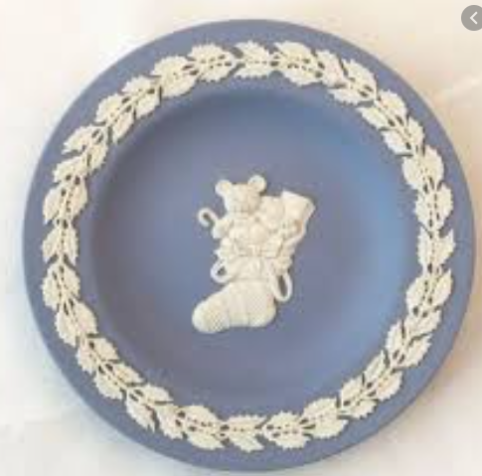

Emma Bridgewater
Most famous design is a white background, decorated with colourful spots.
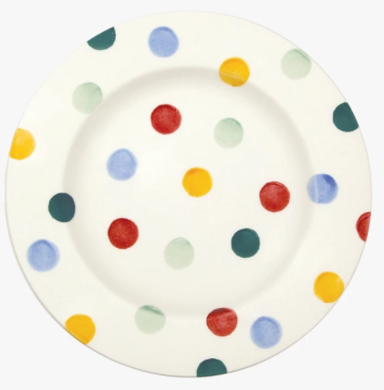

Royal Doulton
Most famous design is Old Country Rose, a floral pattern with a gold trim.
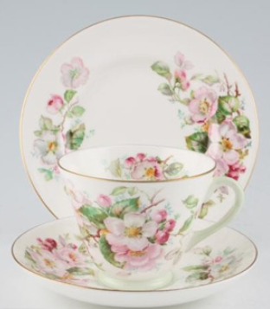

Minton
Most famous design Haddon Hall, lots of flowers with a green edge.
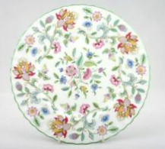

Portmeirion
Most famous design Botanic, flowers and butterflies with a ring of leaves.
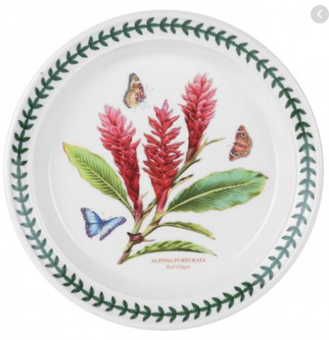

Spode
Most famous design is Blue Italian, lots of dark blue and white details, with the centre being a story picture.
