Phonics Year 1 Letter and Sounds You Tube Channel
Week commencing: 01/03/2021
Day | Phonics link | Covering
Mon  01-03 | 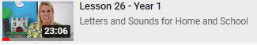 | Review
Tues  02-03 | 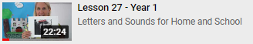 | Review
Wed  03-03 | 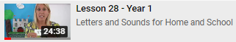 | Review
Thurs  04-03 | 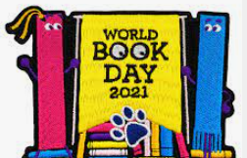 | World  Book  Day
Fri  05-03 | 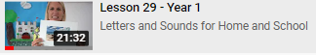 | Review

Control and click on the picture / lesson details to be redirected to the appropriate video.

